F09 Bios Update via IGEL UMS

Download files from link Provided
Extract files from zip.
Import *-Profile.zip file into UMS
Upload UBIOSF09.sh, CN650F09.bin and afulnx_64 files into the “files” section of UMS. Place them in the /wfs/bios/F09/ directory. The Path to the files is CASE SENSITIVE. If it is not exactly the same as below the Linux script will not execute.
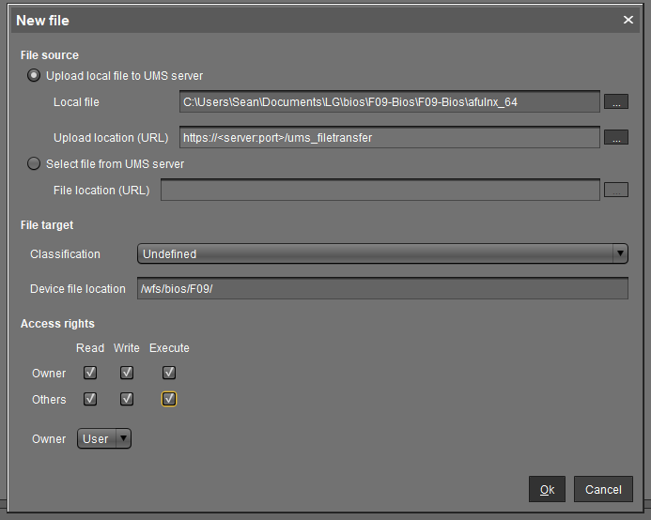

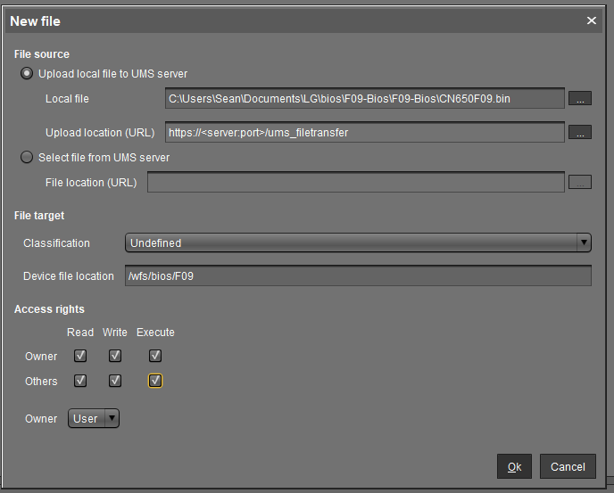

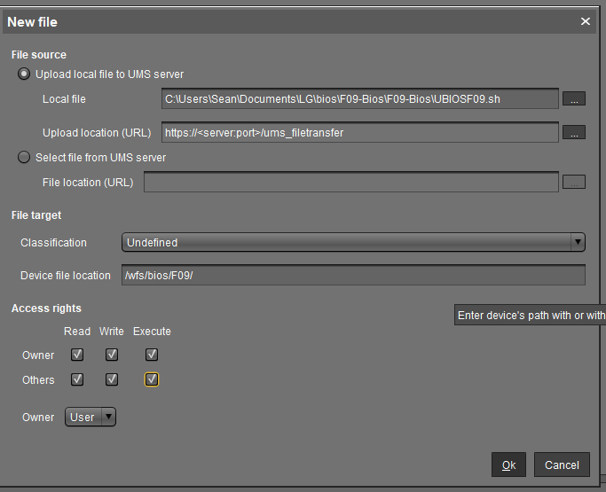

Create a machine directory for the devices needing bios upgrade.
Attach the 3 files you uploaded to this machine directory.
Attach the Profile we imported into UMS to this directory.
Assign Bios Profile to machines or directory of machines and restart machines.

Devices will boot. Once the OS loads the is a 15sec wait and the device will show a window, Bios update in progress do not shut off. Device will reboot, update the bios and then reboot again.

Once device has rebooted, refresh system information in IGEL UMS and verify the new BIOS version.

